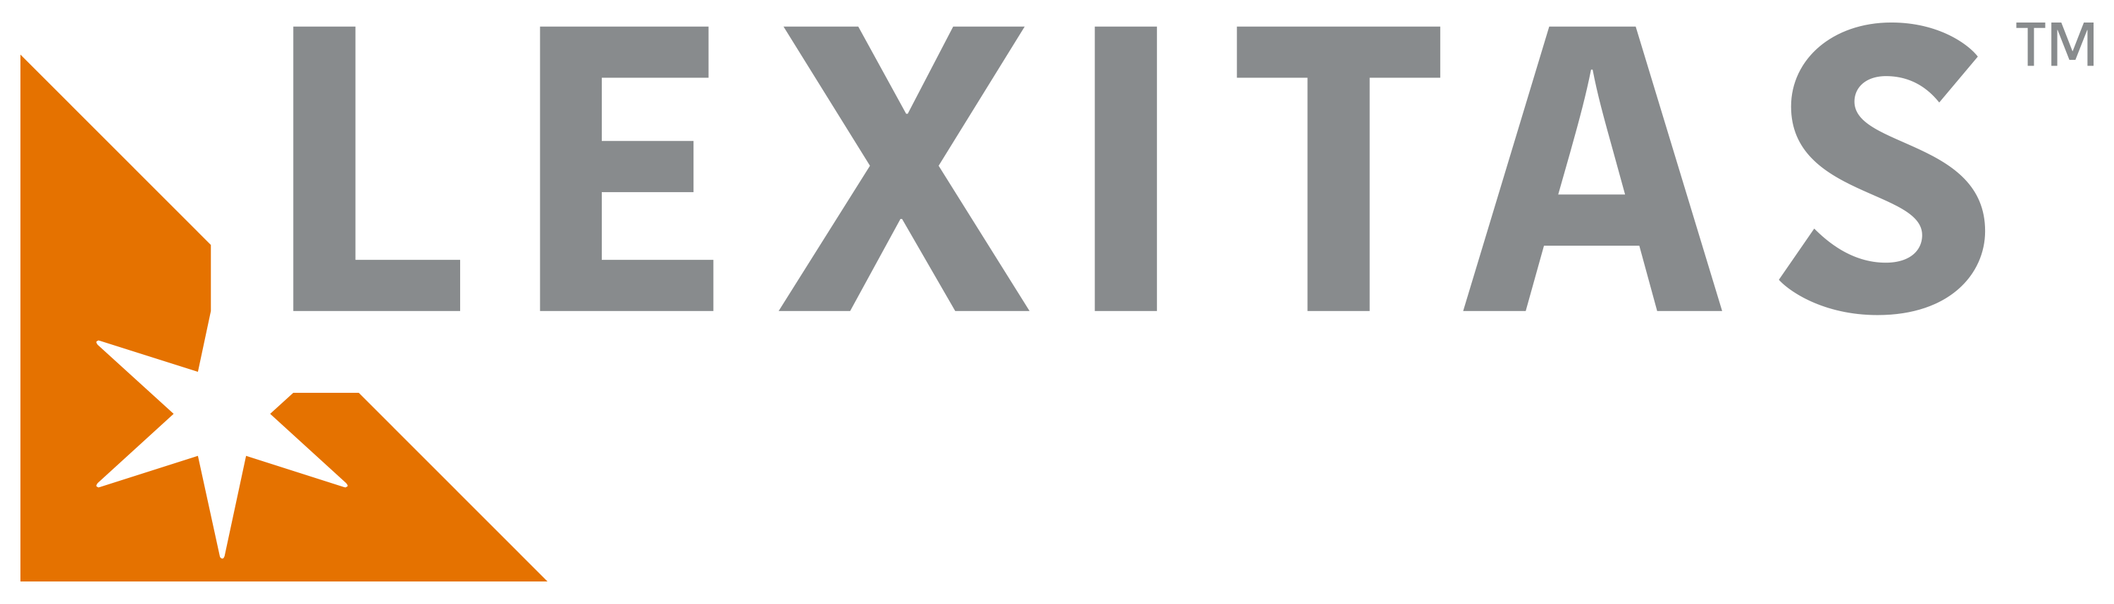
307 29th St NE. Ste 101
Puyallup, WA. 98372-6718
PHONE: 253-445-3400/800-507-8273
FAX: 253-445-4425
EMAIL: wainfo@lexitaslegal.com

Request is for:  (check all that apply) |  | RECORDS |  | BILLING |  | FILMS/X-RAYS/MRI

CLIENT INFORMATION

ATTORNEY

FIRM

CONTACT

ADDRESS

PHONE

E-MAIL

CASE INFORMATION

PATIENT/EMPLOYEE NAME

BIRTH DATE

SOCIAL SECURITY NO.

CASE NAME

FILE/CLAIM NUMBER

CAUSE NUMBER

DATE OF LOSS

ADJUSTER NAME

ADDRESS

BILL ADJUSTER
BILL ATTORNEY

 | Check if RUSH | DATE NEEDED:

PREFERENCES | (Check applicable fields)

 | 1 Copy of Records |  | 2 Copies of Records** |  | Records 3-Hole Punched (Side)
 | Records Numbered* |  | Records Not Numbered |  | Other (please specify)
 | Records Stapled |  | Records 2-Hole Punched (Top)
 | Electronic/PDF format |  | Records 3-Hole Punched (Side)

*Additional cost for numbering
**Additional cost for 2nd copy of records

OPPOSING COUNSEL INFORMATION

ATTORNEY

FIRM

CONTACT

ADDRESS

PHONE

E-MAIL

Records requested from the following facilities:
Name, address, telephone & fax, if available. All records requested unless date range specified below.

